Boughton Park Updates: There’s something for everyone in the Park
Article submitted by Christian Culbertson and Sam Huber

Boughton Park continues to be an oasis across all four seasons for Victor and Bloomfield residents. Thanks to community volunteers, Park Commission members, and collaborations with Victor Hiking Trails, the park has made huge steps toward sustainability and community partnerships.

Effective this spring, Boughton Park is now a “pack-in, pack-out” park. Garbage cans have been removed from the parking lots and we encourage everyone to help with keeping our park clean and natural. Please take any trash (and pet waste) with you when you leave.
Have you seen small colored flags in the woods or along the trails? These mark a newly planted tree! Thanks to a generous donation from Victor Hiking Trails, the Boughton Park Commission has hosted an Arbor Day family tree planting event for the past several years. This year’s event is Sunday April 23rd starting at 9 am. Please be on the lookout for additional details though the school districts, MeetUp, and Facebook.
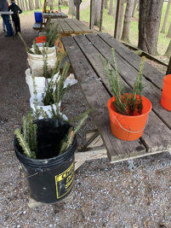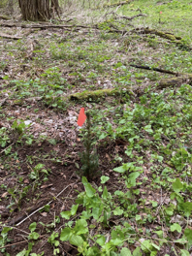
Photo 1: Young trees ready for planting Photo 2: a sapling growing in the woods

Over the past few years, the Park Commission and other volunteers have been spending time in the park to improve trail conditions and make the trails more safe, enjoyable, and sustainable. The work includes removing low hanging limbs, installing culverts to help water drainage, signage, and seating. Between the wind and ice damage and an active beaver population, there are plenty of potential projects for this year. Volunteers are always welcome.
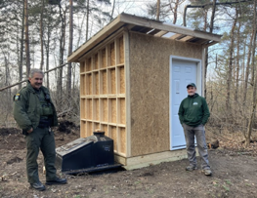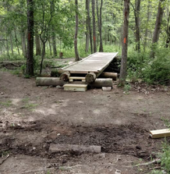
Photo 3: a new restroom near Stirnie Rd Photo 4: a recent trail project
Another large project in the park has been to upgrade the toilet facilities. Being able to remove the traditional porta-potties has been a win for the budget and park experience. Park goers have been very pleased with the new buildings. Over the winter, the third outhouse was built beside the Stirnie Road lot. Many thanks to the build team. Please help us keep these facilities operating well and looking nice for all park users. There have been a few instances of vandalism in the past - let’s work together to keep our park in top shape for everyone.
Boughton Park continues to be a host for community events and competitions. On July 11, 2022 the Canandaigua chapter of Trout Unlimited hosted the Jr. Fishing Bass and Pan Fishing Invitational. The kids and fishing clubs who participated thoroughly enjoyed their time in the park and were able to share important information about the fish population with the Park Commission. The Boughton Park ponds continue to be a great place for anglers year round. Please remember that catch-and-release helps maintain the environment for all of us.
Trail runners have been in the Park as well. On September 25, 2022, the “Unlimited Breadsticks Trail Half Marathon Presented by Yuengling “Flight” utilized the park as part of their extended route. This type of event allowed runners to experience all the wonderful aspects of the park even if they were focused on getting through as fast as possible!
Finally, Boughton Park has been the winter home for some special guests. At least one Bald Eagle has been visiting the park! Keep your eyes up and see what you can spot. If you share a wildlife picture with us on social media, it might end up in the next Boughton Park update! See you in the Park!
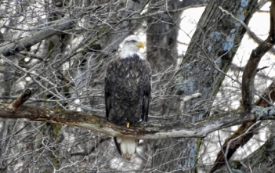
Photo 5: a Bald Eagle perched regally in Boughton Park this winter

Volunteers are always welcome to help with trail maintenance, tree planting, and introducing community members to the park. Follow “Friends of Boughton Park” on Facebook for updates.

